Project Partner Agreement

This Agreement is made on 6th September day of 2019 (“Effective date”)

Between

- Infiniti Systems
Located at 28, Bandal Dhankude Plaza, Bhusari Colony, Paud Road, Kothrud Depot, Pune-38(see Exhibit 1)

AND

- Engineering Student (herein referred to as Project Development Partner “PDP”) to be located at Pune,(See Exhibit 1)

To work for
Exhibit 2 (Title of work): PreciFarm: A complete Integrated Wired and Wireless Solution for Precision Agriculture.

WHERAS Infiniti Systems offers certain business solutions, including the products manufactured and distributed by Infiniti Systems; and

WHERAS PDP wishes to research and design those solutions under the terms and conditions set forth in this “Agreement”; and

WHERAS PDP shall use its best efforts to research and design solution for Infiniti Systems to market the solutions or use in house for betterment of office use.

WHERAS Infiniti Systems would provide sponsorship, consultancy, guide and materials to PDP’s; and for which PDP would take care of material and would be responsible for project completion.

Now therefore, for and in consideration of the mutual covenants and obligations set forth herein; the parties hereto agree to the following terms and conditions (the “Agreement”).

- Consultancy
  - PDP is hereby appointed as a sponsor project development partner to research and design solutions described in Exhibit2; in accordance with the terms and conditions authorized by Infiniti Systems.
  - Infiniti Systems would provide guidance and sponsorship to accomplish the project, but PDP will have to indulge themselves in research and development of project.
  - PDP have to submit progress report related to guidance provided.
  - PDP shall understand that its appointed as sponsor project development partner may be subjected to exclusive relationship that Infiniti Systems may have entered into with other entities.
- Research Program
  - PDP would have to put themselves into research on project and have to find solution for accomplish of project.
  - PDP would use its college resource to research for project development.
  - Infiniti Systems assist in finding solutions when PDPs are stuck in between.
  - Infiniti systems would provide necessary materials, books, software, etc. for research of project
  - PDP during the tenure of this Agreement hall not promote any similar Solution of any other entity.
- Design Program
  - PDP will have to complete the project with designing and assembly idea.
  - Infiniti Systems would provide materials and will bare expense for any materials purchased during the design program.
  - PDP will have to use the materials for designing and development of idea will not misuse or forward the material for any other entity.
- Term and Termination
  - The term of Agreement would be for period of Ten months from date of this agreement. Any termination shall be initiated by either party giving 15 days prior written notice to the other party

  - This agreement may be terminated immediately by written notice from Infiniti Systems as a result of the following conditions:
    - If PDP is declared failure in college,
    - If PDP not shows interest in project development,
    - Fails to find the solutions\ in given time duration as per Exhibit 3.
    - For any other reason as per Exhibit 3
  - Infiniti Systems will not be liable to PDP for any damage, expenditure, loss of material, goodwill, or prospective profits of any kind or nature arising out of such termination.

- Expenses
  - All expenses incurred by PDP in connection with its efforts for research the project idea for Infiniti Systems will be entirely PDP’s responsibility and Infiniti Systems will not be responsible or liable for such expenses.
  - PDP would bear the cost for damages and misuse of the material.
  - Infiniti Systems would bear the cost for design and development of the project idea will provide necessary materials for project completion.
- Confidential Information
  - Infiniti Systems and PDP acknowledge that their course od dealing, each Part may acquire highly confidential and proprietary information about the other Party, its business activities and operations and its technical information and trade secrets.
  - Each Party shall hold such information in strict confidence and shall not reveal the same expect for nay information generally available to or known to the public, known prior to the negotiations leading to this Agreement, independently developed outside the scope of this Agreement or lawfully disclosed by a third party.
  - The confidential information of each party shall be safeguard by the other to the same extent that it safeguard its proprietary information relating to its business.

- Force Majeure
  - Neither party shall be liable or deemed to be in default for any delay or failure in performance under this Agreement or interruption of service resulting directly or indirectly from acts if God or any cause beyond the reasonable control of the acting party.
- General
  - The waiver, amendment or modification of any right, power or remedy hereunder shall not be effective unless in writing and signed by the party against whom enforcement of such waive, amendment or modification is sought.
  - A waiver of any condition of this Agreement by the party shall not constitute a subsequent waiver of such condition or any other term of this Agreement.
  - If any provision of this Agreement is determined by court of competent jurisdiction to be invalid or unenforceable, such determination shall not affect the validity or enforceability of any other part or provision of this Agreement.
- Governing Law and Jurisdiction
This Agreement shall be governed by and construed in accordance with the laws of the Republic of India. Exclusive jurisdiction for litigation of any dispute, controversy or claim arising out of or in connection with this Agreement, or breach thereof shall be only in the State court with competent jurisdiction located in the State of Maharashtra.
- Entire Agreement
This agreement constitutes the entire contract and understanding between the parties with respect to the subject matter hereof and superseded all previous proposals, both oral and written, negotiations, representations, commitments, writings and all other communications between the parties

Exhibit 1

Infiniti Systems declare students as Project Partner, under B.E Program

Sr No. | Name | Phone No. | E-Mail | Roll No. | Batch | Signature
1. | Anil Rajpurohit | 9145614631 | anil.rajpurohit@viit.ac.in | 412043 | B2
2. | Arpit Shrivastava | 7020818025 | arpit.shrivastava@viit.ac.in | 412061 | B2
3. | Vaishnavi Patil | 9011037616 | vaishnavi.patil@viit.ac.in | 412068 | B3

Studying in Final Year B.E

College Address:

Vishwakarma Institute of Information Technology, Kondhwa, Pune.

Signature with Stamp

Project Guide. :____________________________________

Principal/HOD: _______________________________________


Infiniti Systems following engineers to support, guide & provide consultancy to PDPs for project development.

Signature with Stamp

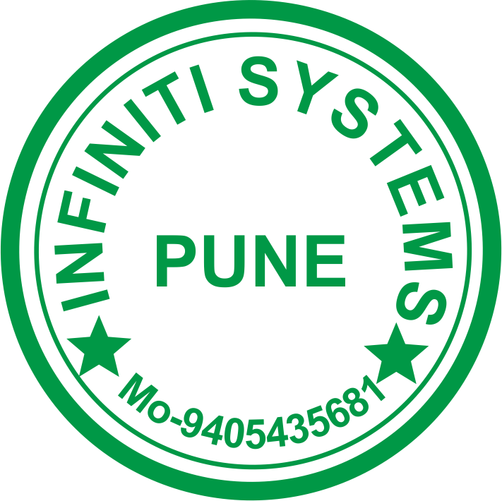
Project Manager / Guide: __________________________________

Exhibit 2
Project Idea
PDPs have to Design PreciFarm as a product.

Abstract:
- To precisely monitor the parameters and build a robust interface in order to increase the overall efficiency of agriculture.
- Automation of the overall process along with increasing the efficiency, in order to increase the yield.
- To commercialize the project into a product for future development in the agriculture industry.

Requirements:

- Node
RFM 96W LORA Module
ATMega 328P-AU
Battery (18650)
Sensor (Soil Moisture, Temperature, EC)
- Access Point
RFM 96W LORA Module
ESP-8266 NODE MCU
Battery (18650) - 3P
Sensor (UV Intensity, Light Intensity, Air Parameters)
Battery Management System
LCD 16*2
SMPS Buck Converter
- Other components, packaging, wires, etc.

Following work is expected from PDP:
Full product design and development with consistency and completion within the defined time limit.

Exhibit 3
 |  |  |  | Terms and Conditions for PDPs:
 | Date of joining |  |  | 20th August, 2019
 | Date of solution submit |  |  | By 22nd September 2019 PDP has to submit complete documentation related to project idea research, which will put guide way to develop the system.  Note: if PDP fails to submit solution on this date, Infiniti Systems hold the right to terminate this agreement
 | Date of 1st demonstration |  |  | PDP has to give first demonstration of project by 10th Nov 2019
 | Date of 2nd demonstration |  |  | PDP has to give second demonstration of project by 22nd Dec 2019
 | Date completion |  |  | PDP has to complete this project by 15th March 2019
 | Idea Publicity |  |  | PDP are not allowed to publicize the project details in any form except their respective project guide. PDP will maintain the idea & details as opaque object with public and would take care of secrecy. PDP can reveal the detail only after project completion.  Note: Infiniti Systems are allowed to take strict actions in case of secrecy not maintained
 | Reporting |  |  | PDP has to report 2 times every week to Infiniti Systems project manager/project leader, either on phone, mail, or personal meetings.PDP has to maintain a register for reporting and material taken along with signature of Infiniti Systems project guide.  Note: At any point of time during project development, project manager holds the rights to terminate the agreement on basis of personal eccentric nature of PDP, technical incapability, frequent delaying on reporting or find PDP not taking interest in project development
 | Accomplishment of Project |  |  | With accomplishment of project, PDP would get individual certificates for accomplishment of project. PDP will also get sponsorship letter to produce in college
 | Copyrights |  |  | Infiniti Systems will hold all the rights for idea & project developed
 | Project Material |  |  | PDP has to submit all the material back to Infiniti Systems after demonstration to their college project guides.
 | Publications |  |  | PDPs are free to publish paper on their work done over project. Also they can present project in various technical exhibitions and competitions.
 | Termination |  |  | In case of termination of this agreement due to any reasons, Infiniti Systems will not provide any certification of project work. PDP has to submit back all documents and materials to Infiniti Systems

